**Linux Assignment on Permissions :**

**Setup :**

**Create 2 users devops1 and demo1**

**Create 3 files in devops1 $HOME_DIR [user:devops1]**

**- devops1_file1.txt**

**- devops1_file2.txt**

**- devops1_file3.txt**

**Create 3 files in demo1 $HOME_DIR [user:demo1]**

**- demo1_file1.txt**

**- demo1_file2.txt**

**- demo1_file3.txt**

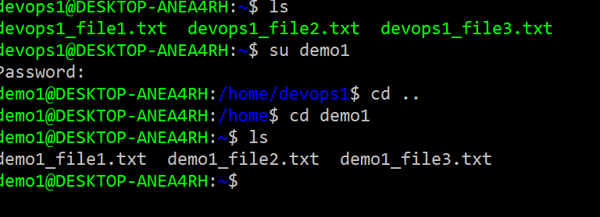

**Case 1:**

**Try to modifying devops1_file2.txt in devops1 $HOME$DIR by [user:demo1] login**

**(Unable to modifiy devops1_file2.txt from demo1 user)**

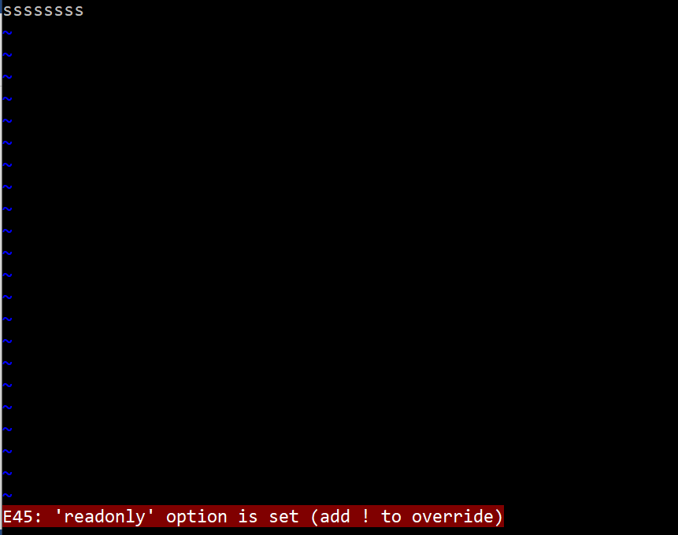

**Change group of [user:demo1] from demo1 to devops1**

**Then Try modifying file2.txt in devops1 $HOME$DIR from [user: demo1] login**

**Case 2:**

**Change the permission to file user3_ file1.txt for others by using symbolic mode.**

**$ chmod o+w user3_file1.txt**

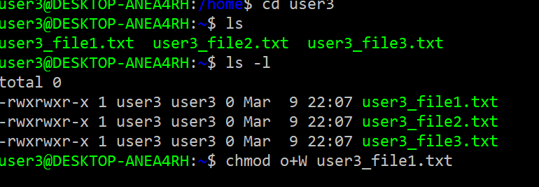

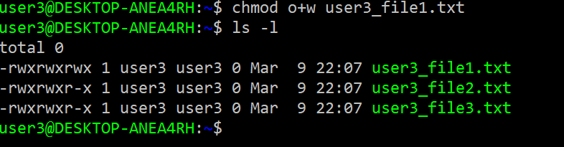

**login into [user: user4]. Now we able to write on user3_file1.txt.**

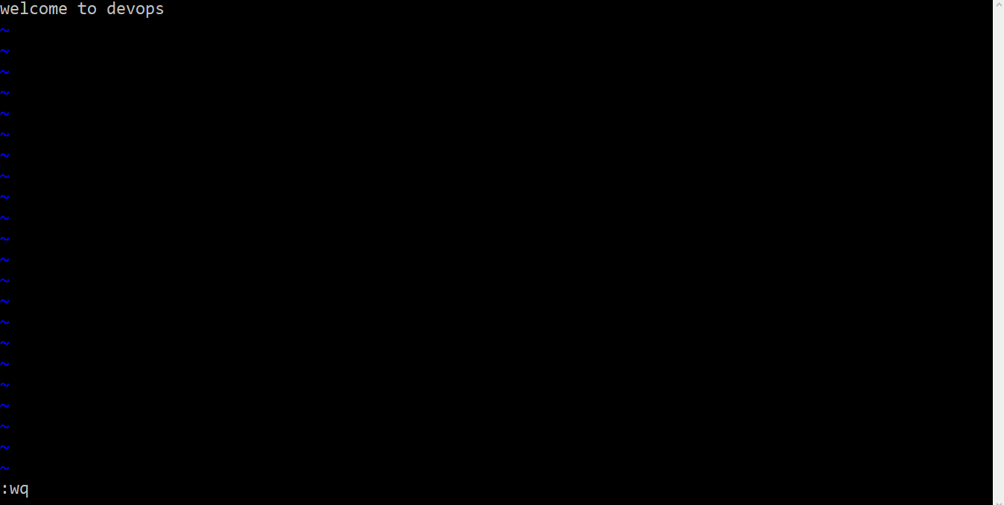

**Case 3:**

**Login into user4 try to write user3_file2.txt**

**$ Vim user3_file2.txt**



**we are not able to edit write in user3_file2.txt**

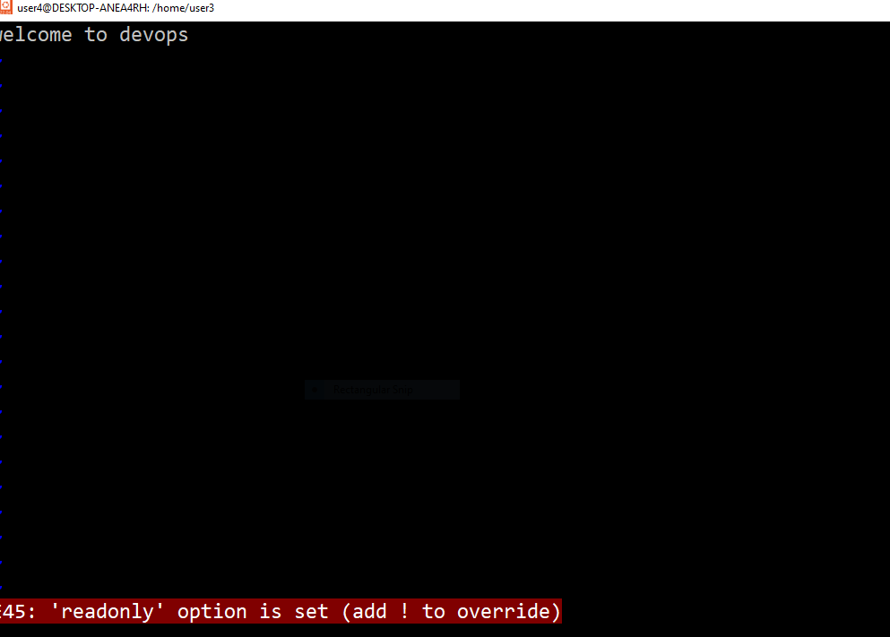

**Now we are changing ownership of user3_file2 user3 to user4**

**Chown user4 user3_file2.txt**

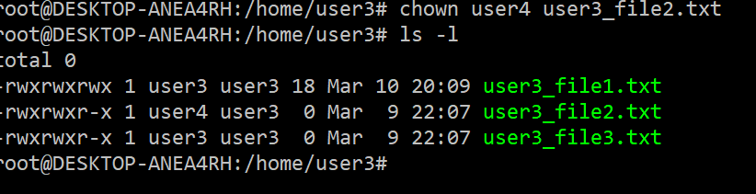

**Login in use4 now we can write in user3_file2**

**Vim user3_file2.txt**



